Report from the Chair

As Chair of the Board of Directors, I am pleased to present my report covering the financial year October 2015 to September 2016. Although this report is concerned with the previous financial year, there are some areas where important developments are continuing into the current year, and where that is the case, I have decided to bring members fully up-to-date rather than wait for next years report.

Location and Identity

Last year, I reported that, following our enforced move from Ilkeston Co-op (our base since July 2007) we had been able to come to an arrangement with DHA (Direct Help & Advice) which, by sharing their Bath Street premises, enabled us to secure a continued, good quality cash facility in Ilkeston, and also to re-locate our main office to significantly improved premises within DHA's main office in Derby.

Leaving our historic base of Ilkeston, and re-locating to Derby was in line with our strategic planning, which recognised the difficulties of securing growth in the geographically dispersed communities of the Erewash and Amber Valley, and was given further impetus by the closure of the Derby United Credit Union.

DHA were very helpful in providing accommodation at a very reasonable rent, and without their support we would have found re-location very difficult. However, at our strategic planning event we concluded that our ability to grow was being hampered by our lack of ‘visibility’ and that, despite the significant cost that would be involved, we agreed to seek premises in Derby that would give us a ‘shop front’. After an extensive search, we eventually decided to take out a lease on retail premises at 38 Cornmarket, Derby, and by the time of our AGM we hope that this will be fully operational.

I reported last year our decision to change our name to ‘Derbyshire Community Bank’, and this we formally did in October 2015 – a change that was accompanied by a new corporate visual identity with re-designed logo and a new colour theme. I am pleased to report that this new name and identity has become well and truly ‘embedded’, and represents our commitment to continue to provide services elsewhere in Derbyshire other than just in the City. In this respect, our customers based in Ilkeston, Ripley, and other towns of the Erewash/Amber Valley sub-region remain very important to us.

Strategic Planning

Our annual planning event was held on 19 September last year, at the Amber Valley CVS premises in Ripley.

The main purpose of the event was to:

- Review the performance and key events of the 2015-16 financial year
- Receive an update on the implementation of the Credit Union Expansion Programme (CUEP), and
- Determine the Strategic Objectives for 2016-17

The remainder of this report will consider these key themes.

1. REVIEW OF 2015-16.

Membership

Changes in our active membership over the year, in comparison with previous years, are shown below:

2014 2015 2016 2016
(active) (active + not yet active)
Ilkeston 1256 1247 1074 1150
Amber Valley 916 981 800 877
Long Eaton 691 674 587 640
Derby City 113 245 219 308
Derbyshire Dales 28 54 69 93

(Definition of Active – a member with a minimum £1 balance)

The reduction in active members appears very stark, but needs to be seen in the context of a much more aggressive approach to closing 'dormant' accounts than was the case hitherto. Along with this, we have to bear in mind our lack of visibility since we moved from our very prominent high street premises in Ilkeston and our 'traditional' geographical markets. In respect of the latter point, and as I flagged up in last year’s report, we closed our Alfreton, Long Eaton and Ripley branches during the year, leaving us with the branch in Ilkeston as our only 'over the counter' operation. These decisions were taken after many months of detailed analysis, and some difficult discussions within the board, but the lack of business undertaken at the branches, combined with the costs and risks associated with cash operations really left us with little choice.

The increased use of ATM's and internet banking has been equally stark over the last year. Despite the fact that we are a long way from having a fully automated on-line system, by December 2015, 74% of our members were using online banking (compared with 37% a year earlier) and almost 100% of new members during the year joined online. Of those members using our website, over 60% were doing so using a mobile device.

Financial Performance

Our financial performance over recent years is shown below:

Year Forecast Out-turn

2013-14 -£58,588 -£39,767
2014-15 -£46,000 -£7,060
2015-16 -£22,000 -£32,815

It is disappointing that last year, for the first time, our outturn was worse than forecast. However, when we take into account the additional legal and other costs associated with the new premises, combined with changes in accounting conventions related to bad debt provisions, our outturn was in line with our forecast. This was, to some extent, foreshadowed in my last report when I noted that:

“we are exploring the possibility of obtaining new retail premises in Derby, which will impact further on our annual costs in advance of any consequent upturn in revenues”.

It is also worth noting that the anticipated reduction in grant funding – related to the severely constrained funding available to local authorities – meant that our income from this source was reduced by about £50,000 in 2015-16.

Despite our disappointing trading performance, we had factored in a dividend payment, and the board is recommending the payment of a dividend of 0.5% for the year.

For the current year, we are budgeting for a deficit of £49,950. This incorporates the additional costs involved in the much higher rental and other expenditures associated with the new premises. It does not include the additional costs involved in implementing the new banking platform as part of CUEP (see below) as these will be realised in the financial years starting in October 2017. The board is well aware that continuing to budget for a deficit will impact upon our reserves, but these reserves are substantial, and can absorb losses of this magnitude for a number of years. Because of this, our overall financial position is sound as far as the regulator is concerned, and this enables us to invest in the future in a way that few other credit unions in the East Midlands are able to. It has to be remembered that prior to the current management regime, we were making substantial losses (£77,000 in 2012-13). The board has taken the view that in order to achieve sustainability, we have to be in a position to embrace the developing needs of our customers - particularly in respect of immediacy and ease of access, and this has driven the investment in new premises and the new banking platform, which will be dealt with below.

As far as our lending activity is concerned, this has been a particularly interesting year. The conventional wisdom emanating from government and based upon research in the sector is that the average credit union loan (around £500 in recent years) is too low to ensure sustainability, and that larger, more longer-term loans are needed. The value of our average loan has grown from around £600 in 2014-15 to £700 in 2015-16, but this increase in the average loan value has not resulted in greater income from loans - the reason being that the changes we made to the structure of our interest rates since last year (from 2% monthly [26.8% APR] to 3% monthly [42.6% APR] have meant that any increase in loan income was contingent upon maintaining the same proportions of low-value loans year-on-year. As the tables below indicate, we had 400 fewer 'low value - high income' loans than the year before, whilst having 21 more 'high value - low income' loans. The impact of this was to reduce our projected loan income from £300,000 to £277,000.

Setting interest rates is much more an art than a science, and requires us to factor in some guesswork about the way rates in the retail banking sector are changing, along with assumptions about the rates our customers could obtain elsewhere, and what they would find affordable, whilst remaining competitive in the marketplace. In the light of experience, and taking account of these factors, the board decided, in October 2016 to raise the rates charged on higher, longer-term loans (£3,000+) from a minimum of 13.4% APR to 26.8% APR, with corresponding increases right up to our largest category loans (£7,500 - £15,000) where APR rates were increased from 3.3% to 13.4%. The impact of rates is kept under constant review, and will be considered again by the board once there is sufficient data to assess the current rates structures.

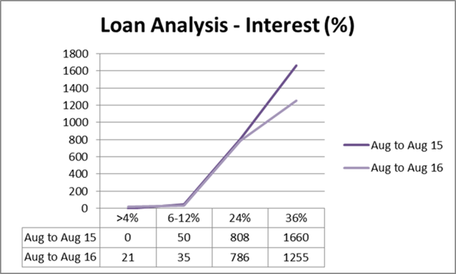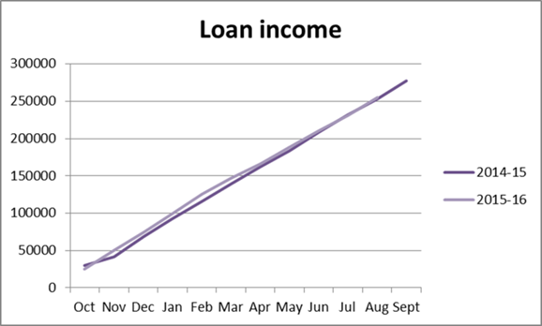

The total loan book value followed an almost identical profile to the previous year. The total value of loans at the year-end stood at £1,370,856 (£1,354,545 in 2014-15) with a peak of £1,446,641 in December - almost identical to the figure of a year earlier

2. ENGAGING WITH THE CREDIT UNION EXPANSION PROGRAMME (CUEP).

I have discussed in previous years reports the government funded initiative (CUEP) to modernise the credit union sector, and our engagement with it. I have also previously outlined the key elements of the project:

- A new banking platform that will support modern requirements for access via portable devices (smart phone, tablet).

- A need to achieve significant operational economies through automated processing (too many of our operations currently rely on manual entry).

- Governance and management systems that operate in a 'business-like' fashion and are able to comply fully with the developing regulatory regime.

The 'roll-out' of this programme, particularly because of the complications involved in developing the banking platform, has been much slower than anticipated, and there have been times when we have questioned whether the supposed benefits would ever be realised. Last year I reported that we expected to be on the new banking platform in June 2016. That date was missed, and we are now expecting to 'go live' in September 2017, though I wouldn't be surprised to see that date shifted further back.

The board has kept the matter under constant review, and in January of this year we had a presentation from Simon Carolan of Cornerstone (the organisation charged with overseeing the project). Basically, although the roll-out has been slower than initially projected, the outcomes, for those credit unions that have gone through the process, have been generally very positive, and we are encouraged by this.

The ability to achieve all of the benefits of what is known as 'straight through processing' (the real-time access we have become accustomed to with high street banks) together with the ability to provide quick decisions on loan applications, and proper interactive on-line access for customers will have enormous benefits for us in a number of areas. For example, it has become clear that our ability to expand 'payroll services' which I discussed in last year’s report, has been severely inhibited by the absence of a modern banking platform.

In addition, and of growing importance is our ability to comply with the increasingly complex regulatory environment of the Prudential Regulation Authority. It is clear, for example, that their developing requirements for credit unions to be able to: 'measure and monitor key financial ratios, and their underlying financial position....and be able to demonstrate this is being done' will be very difficult to achieve, in the form they require, given the analytical tools available to us with our current systems. It is worth noting, in connection with this, that in order to meet the growing regulatory requirements and to professionalise our approach, we recruited to the post of Compliance Officer in April 2016. This post has ensured that: regular staff training is undertaken to ensure staff competence; regulatory updates are implemented where applicable; regular compliance checks are undertaken, and support is given to the role of the Supervisory Committee.

I noted last year, and I re-iterate it again in this report, that, despite the additional costs that will accrue to us over the next few years in implementing new systems, the alternative, which means basically attempting to continue
with outdated manual systems, with little hope of generating the financial returns needed to update our operations, is not considered by the Board to be a practical way forward.

And finally...

Our ability to maintain our operations in 2015-16 would have been seriously restricted without the help of a number of partners, in particular: Direct Help & Advice (DHA) (formerly Derbyshire Housing Aid), Derbyshire County Council (who continue to provide valuable promotional assistance), Derby Homes, Derbyshire Dales District Council, Dales Housing and Amber Valley Borough Council.

In addition, I would like to make special mention of:

Lynn Allison, Chief Executive of Amber Valley CVS who has again been extremely generous in allowing us the use of their premises, and providing general support over a range of areas, particularly in respect of employment matters, and

John Davis, Dean of Derby Cathedral, who, in addition to providing us with the magnificent setting of the Cathedral for last years AGM, also allowed us to use his premises for a number of meetings, including that of the east Midlands Credit Union Forum. We wish him well in his new post.

The comments I made last year, about the world of the Credit Union movement becoming increasingly challenging and complex still apply. The struggle to secure profitability, along with the widespread problem of debt delinquency and the significant competition from other financial institutions such as 'payday' lenders is a familiar backdrop. With this in mind, I would convey my appreciation of the professional and dedicated approach taken by our Chief Executive Officer and her team, in continuing to develop and modernise the operations of the Credit Union, along with my sincere gratitude to my colleagues on the Board of Directors, and the Supervisory Committee, who meet regularly to steer us in the right direction, and also, of course, to our members, without whom none of this would exist for the local community.

Mick Brown
January 2017

