Report from the Chair

As Chair of the Board of Directors, I am pleased to present my report covering the financial year October 2019 to September 2020. Although this report is concerned with the previous financial year, there are some areas where important developments are continuing into the current year, and where that is the case, I have decided to bring members fully up-to-date rather than wait for next years report.

The year in brief

The 2019-20 financial year was unlike no other in the history of the credit union, due to the impact of the coronavirus pandemic. This impact was threefold: firstly, there was an immediate reduction in borrowing by members, which did not recover until September; secondly, from April, staff were largely working away from the office, which had significant management implications, and finally, we received some important financial support to underpin our loss of income - both from the government 'furlough' scheme, and also via the Business Support grant from Derby City Council, which was also a centrally driven initiative to support organisations suffering the effects of the pandemic.

Reduction in loan income

The chart below indicates total loan allocations across two financial years (2018-19 and 2019-20), coded green where the figures exceed those for the same month in the previous year, and red where they are lower. It is clear that by February 2020, lending - which provides us with our income - had been extremely healthy for most of the previous year. By April 2020, loan income was £17,000 above target for the financial year and our projections for the year were looking very healthy. However, the imposition of 'lockdown' restrictions led to an immediate fall in lending (in excess of 60%) and lending levels didn't recover for another five months. By the end of the financial year, in September 2020, our loan income was still above target, but by only £5,000, which represented a loss of £12,000 in our income projections.

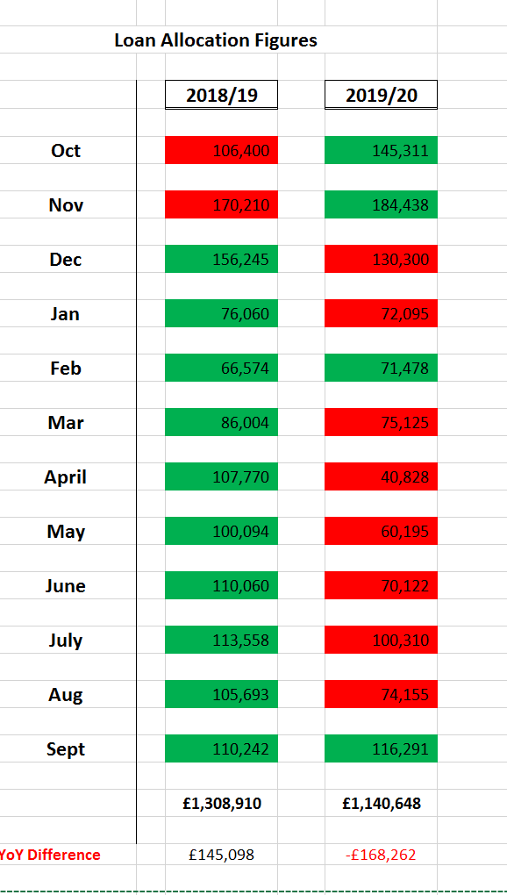

Staffing Implications

By April, the requirement for staff to work from home, if possible, mean that staffing levels at the office were very low from then until the summer, when 'normality' was briefly resumed before staff resumed remote working again with the re-imposition of restrictions in the autumn. This was particularly complicated by the fact that Sara was unable to attend face-to-face meetings in the UK due to health considerations, and Sharmillar Fearon, our new operations manager had only just joined the staff! Continuity of service was, therefore, difficult, but it was impressive to see the ways in which staff collectively managed to achieve this.

Financial Support

The dramatic reduction in lending, and other activity generally, meant that we would have had staff seriously under-employed, and at risk of redundancy, without the financial support provided by the furlough scheme. In all, we received wage compensation to the tune of £5,000 for the period to July 2020, which enabled us to retain all staff. In addition to this, we were fortunate to receive a grant of £25,000 from Derby City Council to compensate for our loss of income.

The second period of 'lockdown restrictions have not, thankfully, seen the collapse in lending that we, and other credit unions, experienced in April 2020, but we are still, in February 2021, struggling to consistently match the lending levels of two years earlier, and our loan income remains some £9,000 below a projected figure that had already been revised downwards. This will be explored further in next year’s report.

Membership

Given the curious nature of the year, membership trends are difficult to discern, apart from the obvious one, that Erewash/Amber Valley membership continues to decline, whereas Derby based members continue to grow, albeit at a much slower rate than in the previous year - to what extent this slowdown relates to the fact that we were devoid of a high street presence for much of the year is impossible to say.

The other main point to note from the figures, is the positive impact of the Moneyspider merger, which brought in an additional 196 members. Without these new members, we would have been reporting an overall decline in membership of 55 (1.8%). The pandemic did interfere significantly with the promotional activities we would normally be involved in through the summer months, and although we did draw up a new marketing strategy for 20-21, we didn't envisage the second period of 'lockdown', which has seriously interfered with our ability to co-ordinate activities to deliver the plan. We are hopeful, however, that Spring 2021 will see a return to something approaching 'normal'.

In previous reports, I have noted the switch from 'over-the-counter' to 'on-line' transactions in terms of new membership growth, cash deposits and withdrawals, and applications for loans. Out of 3,200 adult members, 2,688 are entirely 'online' account holders, and online loan applications, which numbered 41 in total in 2017-18, are now running at 2,550 for the 2020-21 financial year, which still has 6 months to run!

In this respect, 2020-21 will see us needing to undertake a serious re-assessment of our need for high street premises - currently costing £50,000 a year (£30,000 lease plus £20,000 utilities, rates and insurance etc). Our lease agreement has a break clause at the end of 2021, which would have to be activated in June, and we are currently carrying out a detailed analysis of 'footfall' versus 'remote' activity. Given that we are constantly refining our ability to work remotely, we have to question whether retaining the current premises is a sound idea.

 | Sept 2018 | Sept 2019 | Sept 2020 | +/- | % change  2018-19 | % change 2019-20
Ilkeston | 1209 | 1125 | 1068 | - | -7.0 | -5.1
Amber Valley | 832 | 789 | 715 | - | -5.2 | -9.4
Long Eaton | 596 | 553 | 528 | - | -7.2 | -4.5
Derby | 396 | 520 | 611 | + | +31.3 | +17.5
Sth Derbys |  |  | 196 | + | - | +100
Total | 3033 | 2987 | 3118 |  | -1.5 | +4.4

Junior membership currently stands at 185, with corporate membership at 36, and payroll membership fairly static at 34.

Shareholding

As can be seen from the table, our total shareholding reduced significantly in 2018-19 due to the decision we took in April 2019 to reduce our ISA’s interest rate to 0.75% and keep the fund closed to new applications - hence the significant share reduction. I did note, in last years report however, that from 1st October 2020, shareholding would increase as a result of the Moneyspider merger, and this effect is clear from the table.

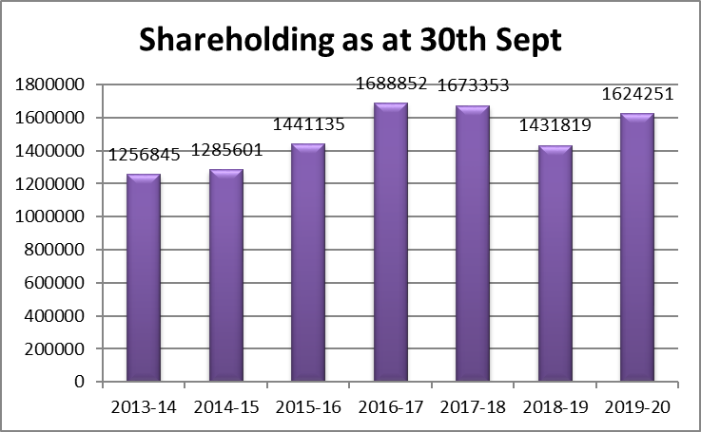

Lending

Value of lending has declined significantly:

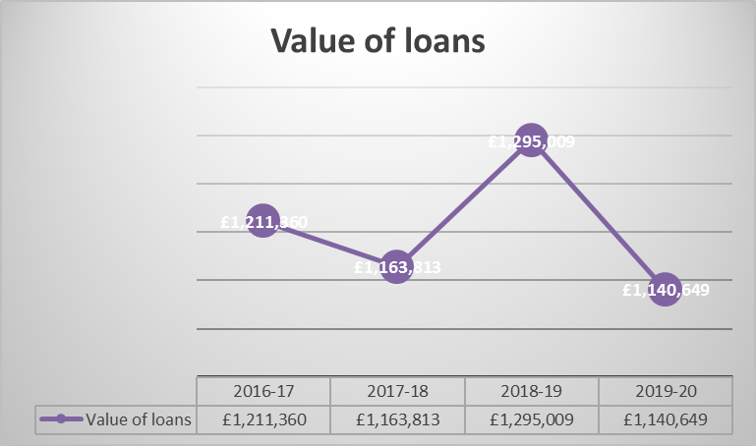

This table clearly illustrates the impact of the reduced levels of lending between April and September 2020 - in fact, overall lending in terms of value, was at its lowest level for 8 years.

Interestingly however, the number of loan approvals only declined marginally from the 2018-19 level, and exceeded the levels recorded in the previous two years. The implication of this is that the average size of loans has continued to decline, as confirmed in the table below. This is no accident since, as I recorded in a previous report, we made a policy decision on 2018-19 to move away from higher value loans, for a number of reasons, the chief one being that, given a fairly consistent rate of default across all lending, the impact on our overall bad debts of higher value debts becoming delinquent was becoming unsustainable.

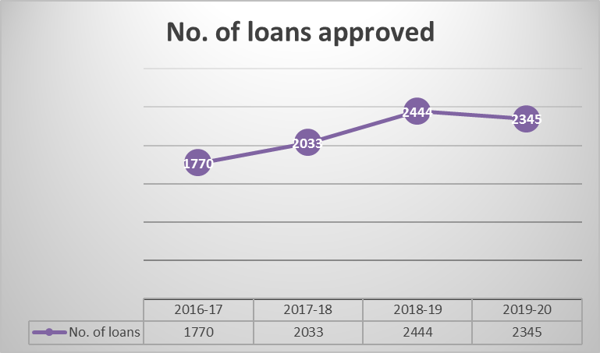

Average loan size

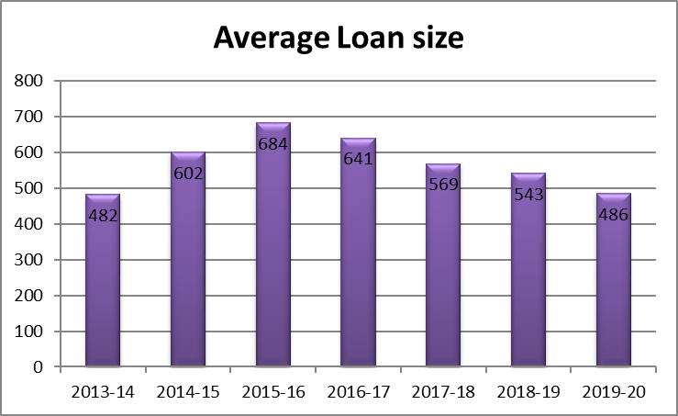

Loan income

It is interesting that although our total lending in 2019-20 was £155,000 below that of the previous year, our loan income (see below) was £44,000 higher. This is because the income from lending in any one year relates partly to the lending in that year, but mostly to loans agreed in previous years, and the preceding year (2018-19) was a good year, in that, for three-quarters of that year, our lending was above that for the corresponding months in the previous year.

This is the principal reason why we need to be cautious in both our projections and our commitments for 2020-21 and beyond, since we know that the significant drop in the value of lending will continue to be felt for some time in terms of our income line.

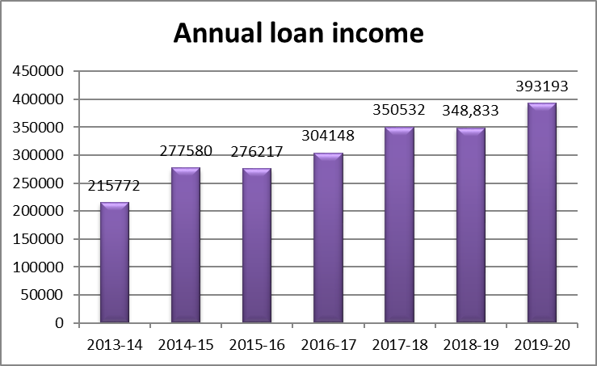

2. FINANCIAL STRATEGY AND PERFORMANCE

Our financial performance over recent years is shown below:

Year Forecast Out-turn

2014-15 -£46,000 -£7,060
2015-16 -£22,000 -£32,815
2016-17 -£49,950 -£119,367
2017-18 -£37,561 -£66,590
2018-19 -£19,629 -£236
2019-20 £3,127 £69,560

The financial position for 2019-20 was the healthiest we have seen for many years. This was partly due to the very healthy lending performance in the first six months of the year, and partly as a result of the financial support received from government sources.

If we subtract the £25,000 business support, and the £5,000 furlough support, our surplus falls to £39,500, and if we subtract from this the £29,800 'one - off' injection to our income inherited from sundry 'Moneyspider' balances, our actual 'trading' surplus was around £10,000. If we add back the £12,000 minimum loss of income as a result of reduced lending, our actual trading surplus for the year would have been in the region of £20,000. It is impossible however to quantify any additional loss of income as a result of 'footfall' largely disappearing from the city centre office for six months of the year.

Although the financial position looks strong, we are aware that we are starting the new financial year with significantly reduced loan income, and it is, as yet, impossible to quantify the impact of this, plus the 2021 'lockdown' on our eventual financial outcome, and hence, on our reserves. Consequently, and with a great deal of reluctance, the board is recommending that we are not in a position to announce a dividend for the year.

Year end Reserves

Audited Reserves of £312,958 remain strong, particularly due to the £70,000 addition to reserves as a result of the financial surplus. Our hope is that an improved trading position following the end of the 2021 'lockdown' will enable us to see out the financial year without having to draw from our reserves

Bad debt written off

Arrears on loans continue to be an issue and seems to reflect the economic climate, which continues to report increasing personal debt issues including higher levels of bankruptcy and other types of debt arrangements.

As I have indicated in previous years reports, the severe problems associated with loan arrears and bad debts are by no means unique to ourselves - they are being experienced across the credit union movement.

However, we are not complacent, and the various steps and measures we have initiated in recent years to mitigate and reduce debt delinquency, continue to be operative.

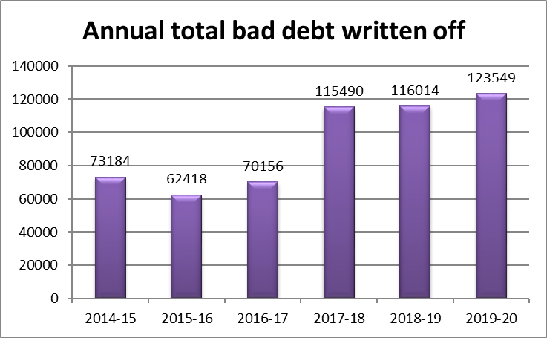

Year end 'CREDS' ratios

'CREDS' is shorthand for the 'Credit Union Sourcebook' which, under the auspices of the Financial Conduct Authority (FCA), represents the rules and guidance specific to credit unions. Following the change of regulator, from the Financial Services Authority (FSA) to the Prudential Regulation Authority (PRA) and Financial Conduct Authority (FCA) in 2013, a set of ratios were introduced in 2016 by the PRA following a review of the CRED. These ratios provide one of the key yardsticks by which the performance of individual credit unions is measured, and they are reported to, and discussed monthly by, the board.

As the table below illustrates, the CRED ratios for DCB remain within the regulatory indicative limits with the exception of ‘Net loans as % of total assets’, however this remains slightly above the peer average of 58.4%.

Key financial ratios as at 30th Sept 2020:

 | Regulators indicative ratio | Sept 2020
- Financial Performance
- Capital as % of total assets | 10%* | 16%
- CU’s borrowing as % of total assets | </= 5% | nil
- Total shares as % of total assets | >/= 70% & </=90% | 84%
- Total bad debt written off (over 12 months) as % of total loans (projected) | </= 10% | 8%
- Net assets as % of sum of total shares & juvenile deposits | >/= 105% | 120%
- Bad debt (more than 3 mths in arrears) as % of total loans | </=20% | 13%
- Non-earning assets as % of total assets | </=10% | 0.5%
- Net zero cost funds as % of non-earning assets | >/=200% | 3628%
- Loan income over 12 months as % of total loans | >/=6% | 31%
- Net loans as % of total assets (Peer ave 58% Q1 2020) | >/= 70% & </=80% | 59%

And finally...

Our ability to maintain our operations in 2019-20 would have been seriously restricted without the help of a number of partners, in particular: Derbyshire County Council, Derby Homes, Derbyshire Dales District Council, Amber Valley Borough Council and Derby City Council.

The comments I made last year, about the world of the Credit Union movement becoming increasingly challenging and complex still apply. The struggle to secure profitability, along with the widespread problem of debt delinquency and the significant competition from other financial institutions such as 'payday' lenders is a familiar backdrop. To this we must now add the challenges of the pandemic.

With this in mind, I would convey my appreciation of the professional and dedicated approach taken by our Chief Executive Officer and her team, in continuing to develop and modernise the operations of the Credit Union, along with my sincere gratitude to my colleagues on the Board of Directors, who meet regularly to steer us in the right direction, and also, of course, to our members, without whom none of this would exist for the local community.

Mick Brown

Chair
March 2021

