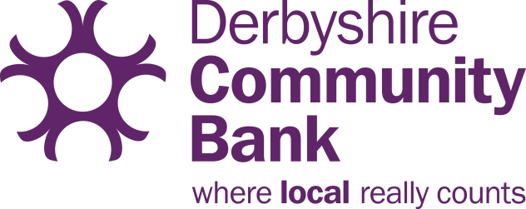

Derbyshire Community Bank
CUBO, The Old Post Office
Victoria Street
Derby
DE1 1EQ
01332 348144
info@dcbank.org.uk
www.dcbank.org.uk

CORPORATE ACCOUNT SHARE WITHDRAWAL FORM

- Share withdrawals will only be made where there are sufficient funds available.
- All forms must be completed and signed by two of your authorised signatories.
- A scanned copy of this form will be acceptable. Please email to: info@dcbank.org.uk
--------------------------------------------------------------------------------------------------------------------------------------

Corporate Member: ____________________________ Membership no: ____________
Address: ___________________________________________________________________
_______________________________________________________________________
Post Code: _______________ Tel No: _______________________
Amount of share withdrawal £ ___________
Close account? Yes/no
Withdrawal options:
Withdrawals are paid by BACs. Please enter the account details to which you with the payment to be sent:
Account name: ____________________________________

Sort Code: _ _-_ _-_ _

Account no: _ _ _ _ _ _ _ _

Authorised signatories:

Name:____________________________ Name: ____________________________

Signed: ___________________________ Signed: ___________________________

Date: ___________________________ Date: ___________________________

For Office use:
Balance checked……………………………Date…………………………….
Input by………………………………………..Date……………………………..

Erewash Credit Union Ltd is authorised by the Prudential Regulation Authority and regulated by the Financial Conduct Authority and the Prudential Regulation Authority. Registered number 432447. Registered Company No. IP00730C on the Mutuals Register.. Member of the Financial Services Compensation Scheme and Financial Ombudsman Service.

